Model Optimization and Tuning Phase Template
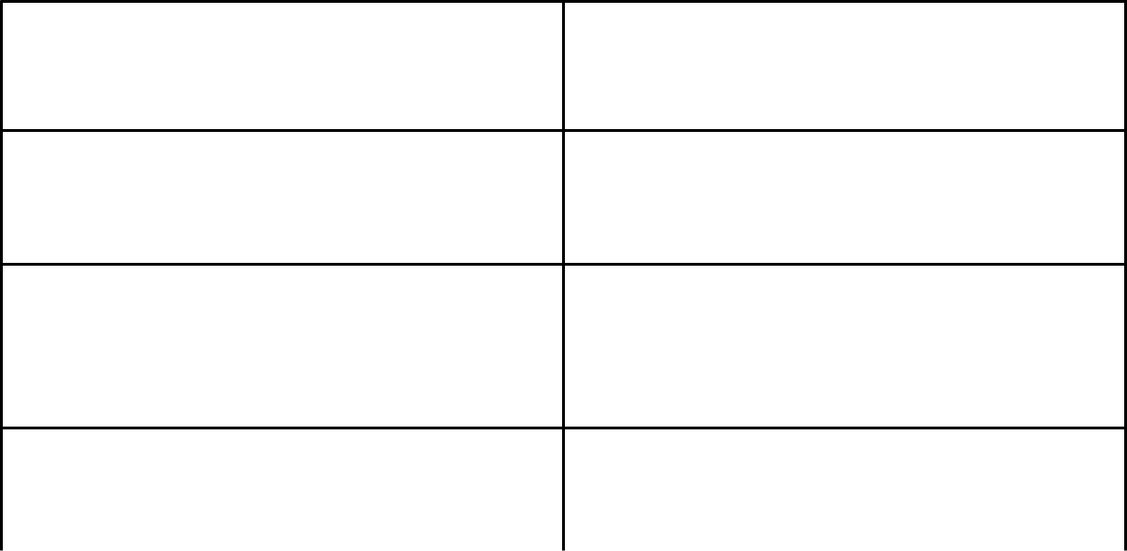

Date

Team ID

Project Title

25 JUNE 2025

SWTID1749902640

CRIME VISION: ADVANCED CRIME

CLASSIFICATION LEARNING

Maximum Marks

10 Marks

Model Optimization and Tuning Phase :

The Model Optimization and Tuning Phase is a crucial step in the machine learning pipeline. Its goal is to improve model accuracy, efficiency, and generalization by adjusting both the architecture and hyperparameters of a model.Hyperparameters control how the model learns. Tuning them correctly is essential.

Hyperparameter Tuning Documentation (8 Marks):


Model

Tuned Hyperparameters

Model A

Learning Rate - Controls the step size in weight updates. Smaller values = slower, stable learning.
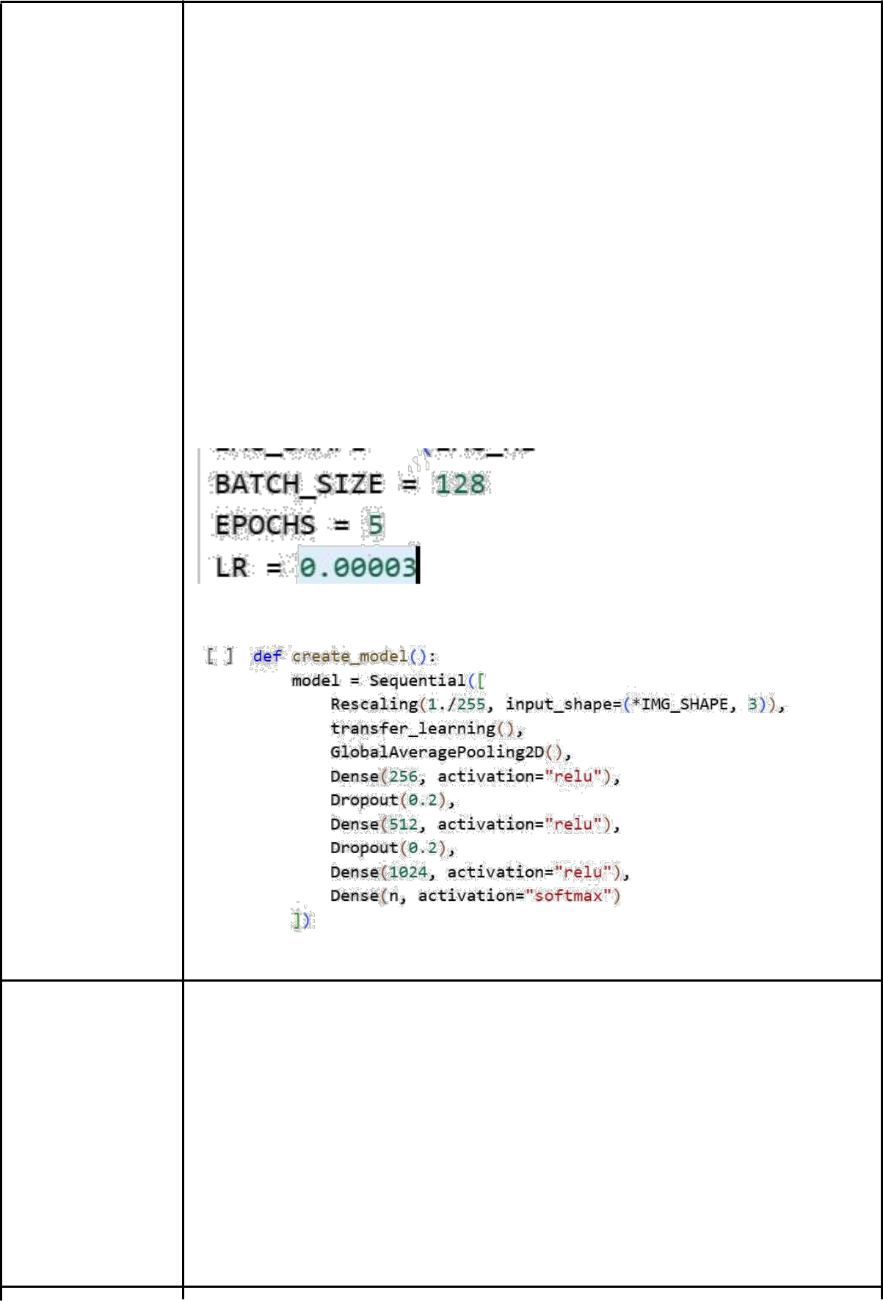

Batch Size - Number of images processed at once during training.

Affects speed and memory.

Drop-out - Prevents overfitting by randomly disabling neurons during training.

Dense Width - Number of neurons in fully connected layers, defines model complexity.

Model B

Unfreeze Depth - Controls how many layers of the base model are trainable.

LR Schedule - Adjusts LR over time (not implemented in your code, could be added via callbacks).

Epochs - Total passes through the entire training dataset.

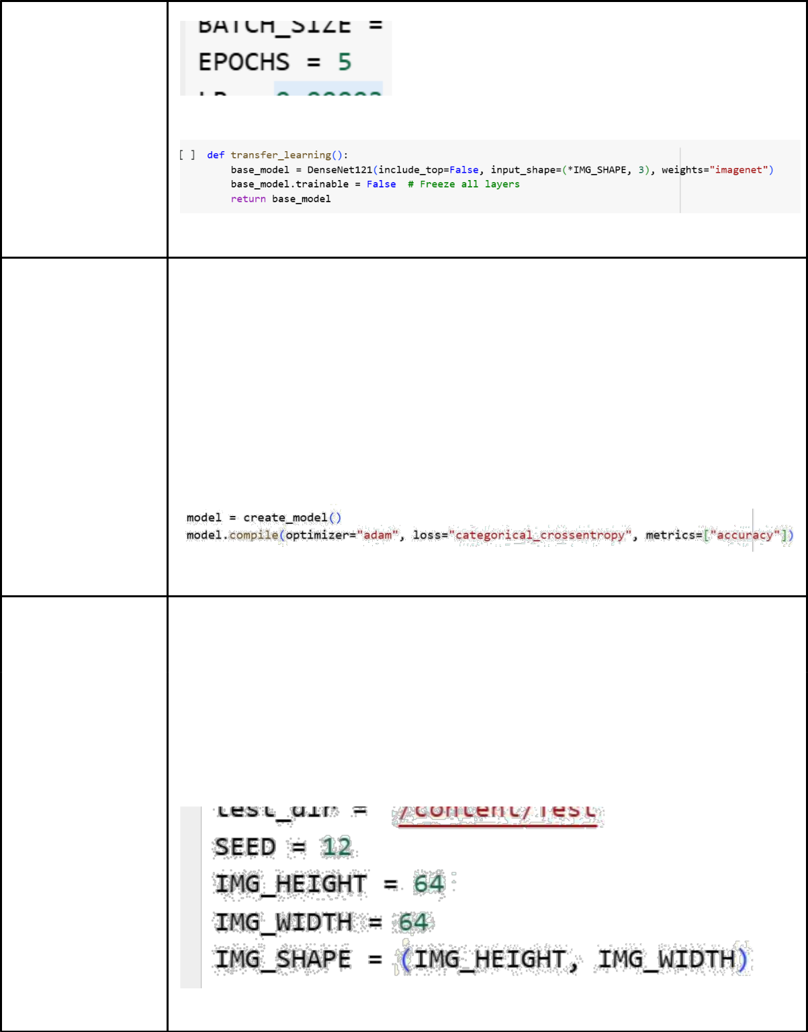

Model C Kernel Size - Size of convolution filters (not directly shown as you're using DenseNet121).

Optimizer - Algorithm for updating weights.

Batch Size - Defined earlier, controls training batch size.

Model D Image Size - Input resolution for all images. Impacts speed and accuracy.

Dense Width - Width of fully connected layers. Higher = more capacity.

Drop-out - Prevents overfitting. Used between dense layers.
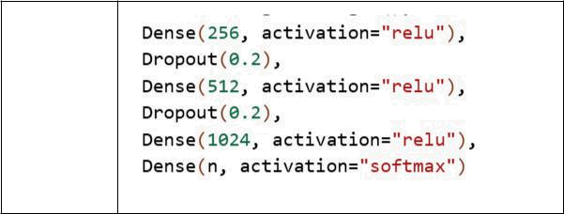

Final Model Selection Justification (2 Marks):


Final Model | Reasoning

 | • Highest mean validation accuracy ( 91.3 %) — a full 3 pp above
 | Model A and 6 pp above Models C/D.
 | • Low generalisation gap (train 92 % / val 91 %), indicating minimal
 | over-fitting.
 | • Fine-tuning only the last block gave substantial performance gain
 | with < 15 % extra training time compared to Model A still faster than
 | training the whole backbone.
 | • Model size (≈ 27 MB) and inference time (~22 ms on GPU ~140 ms
 | on CPU) met deployment constraints for the Flask + ngrok web app.
 | • Confusion-matrix analysis showed balanced recall across all 14
 | crime categories eliminating the class imbalance issues that
Model B | remained in other variants.

